Task 1

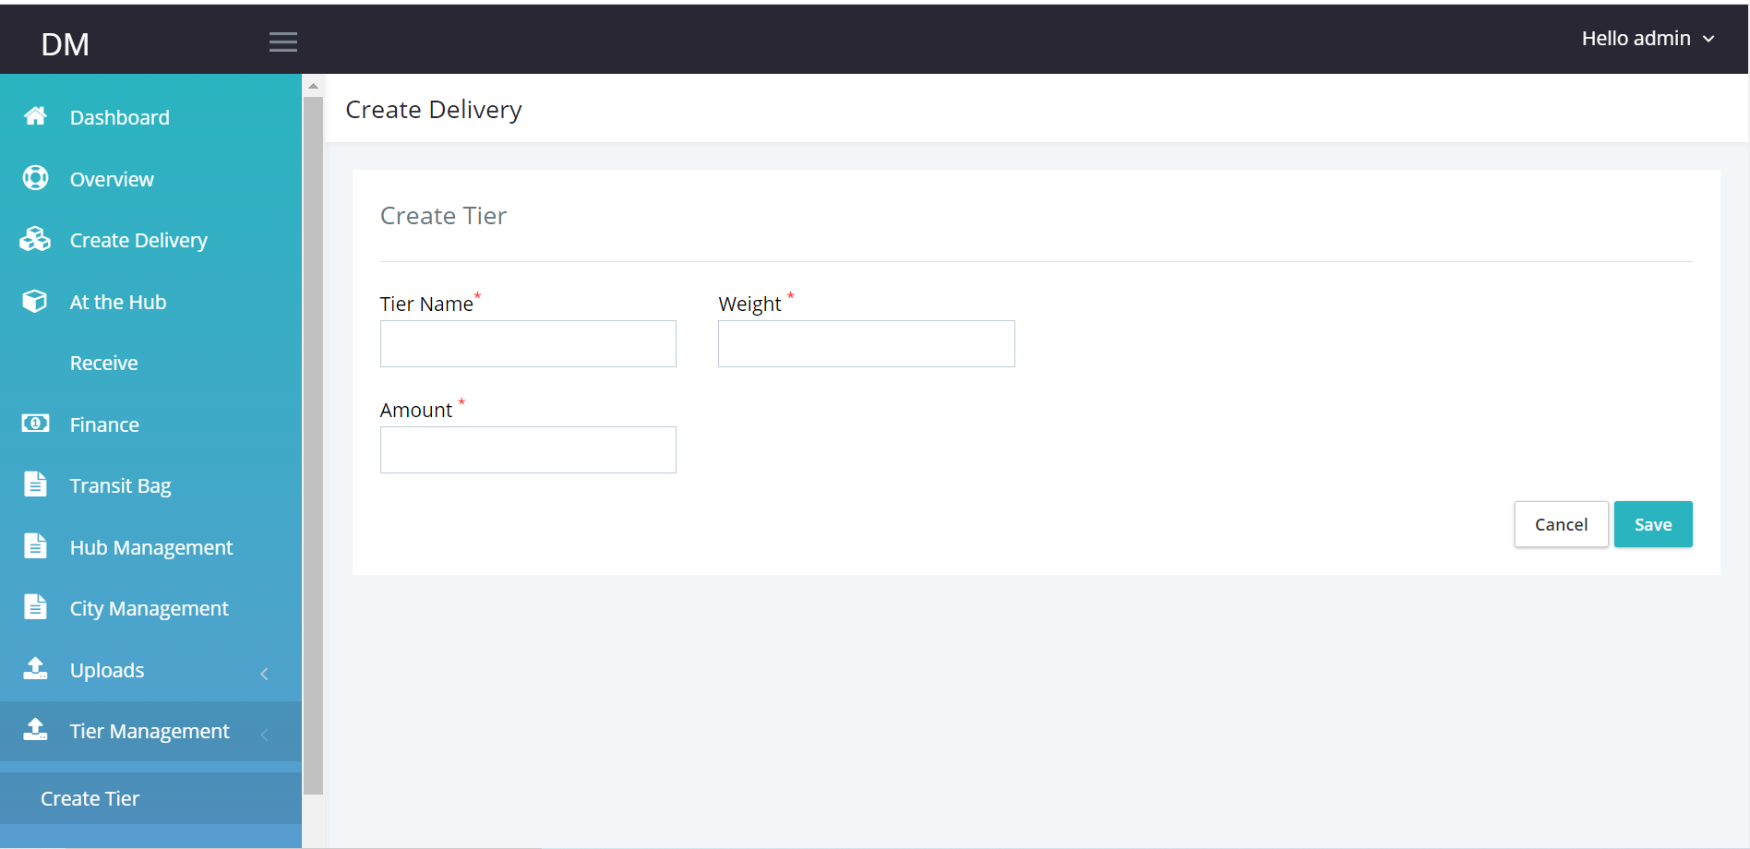

Create Tier Tab: This tab currently does not work.

Make tab accept inputs and store data in the data base.

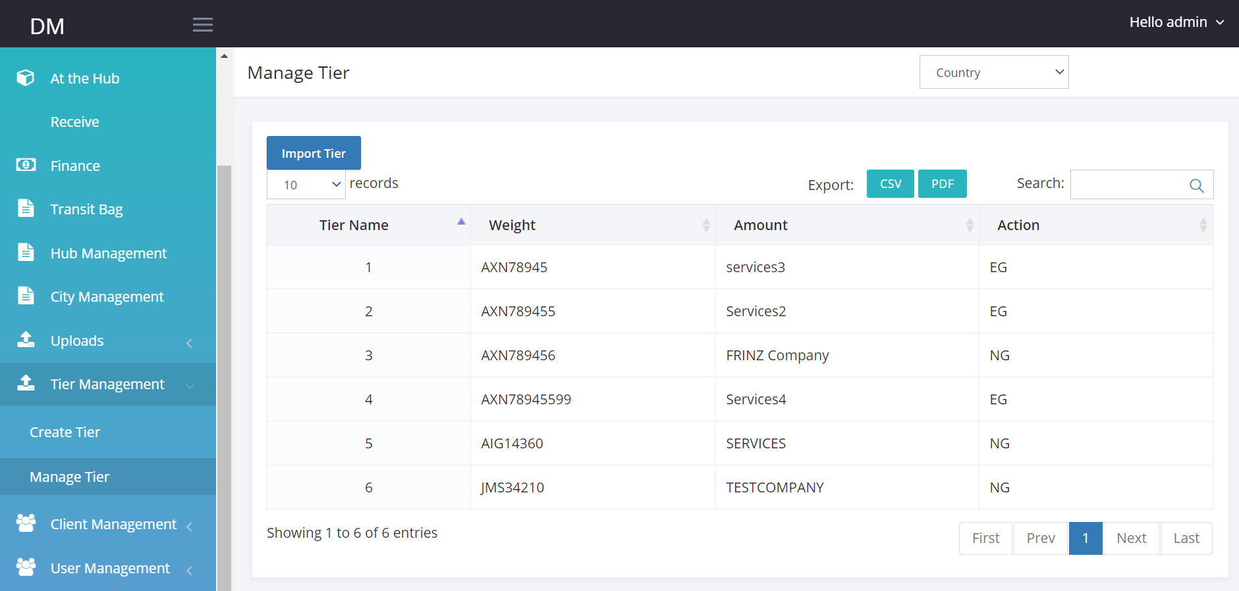

Edit

Edit

Edit

**Manage Tier:** Enable tier management.

When Tier is created using the tier Tab, I should see all tiers on the manage tier table.

I should be able to edit each listing.

Import Tier should allow me import tier data.

Zone Management

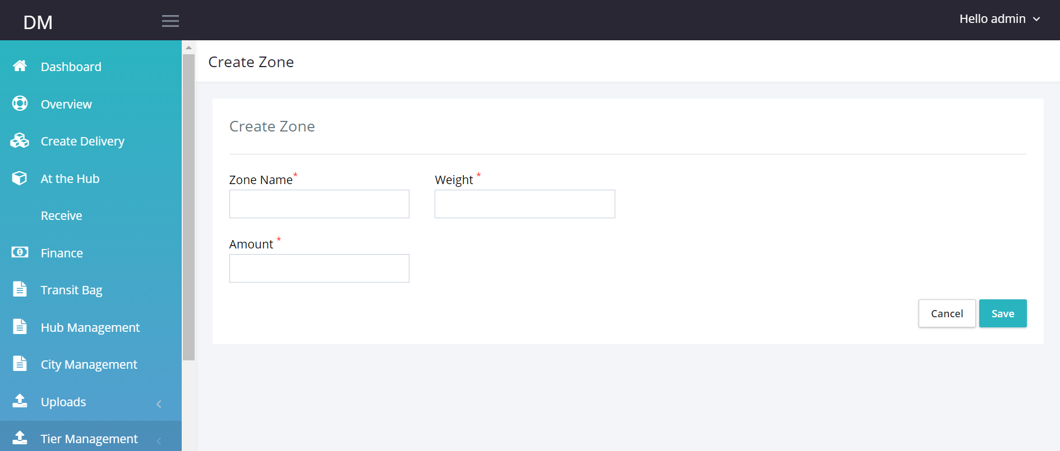

**Create Zone:**  Make zone page receive and store data.

**Manage Zone:**

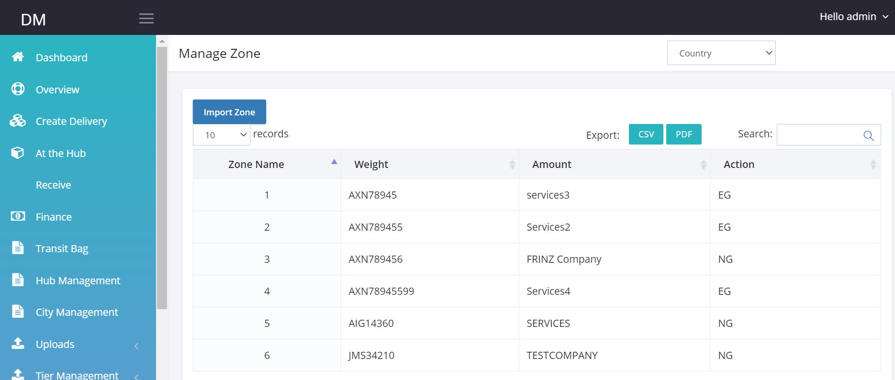

Edit

* Enable data from Zone table visible on manage zone tab
* Import Zone: I should be able to import new zone data or update zone data using csv.

Edit

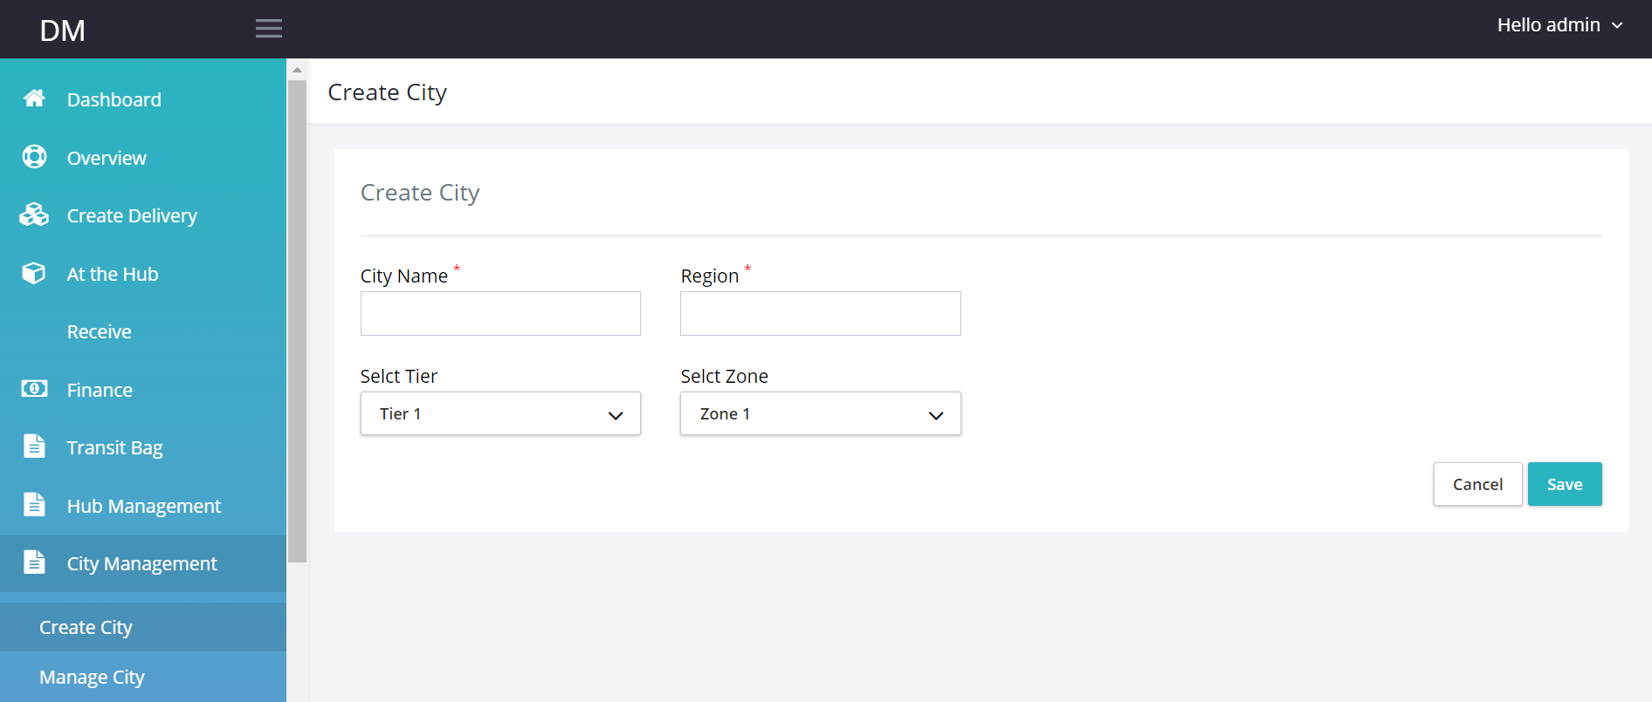

**Create City Tab:** Add city tab to the menu.

Make input boxes work.

Select Tier: This should be from available data on tier management table-should be searchable box

Select Zone: This should be from the available data on Zone management Table should be searchable box.

**Manage City Tab**

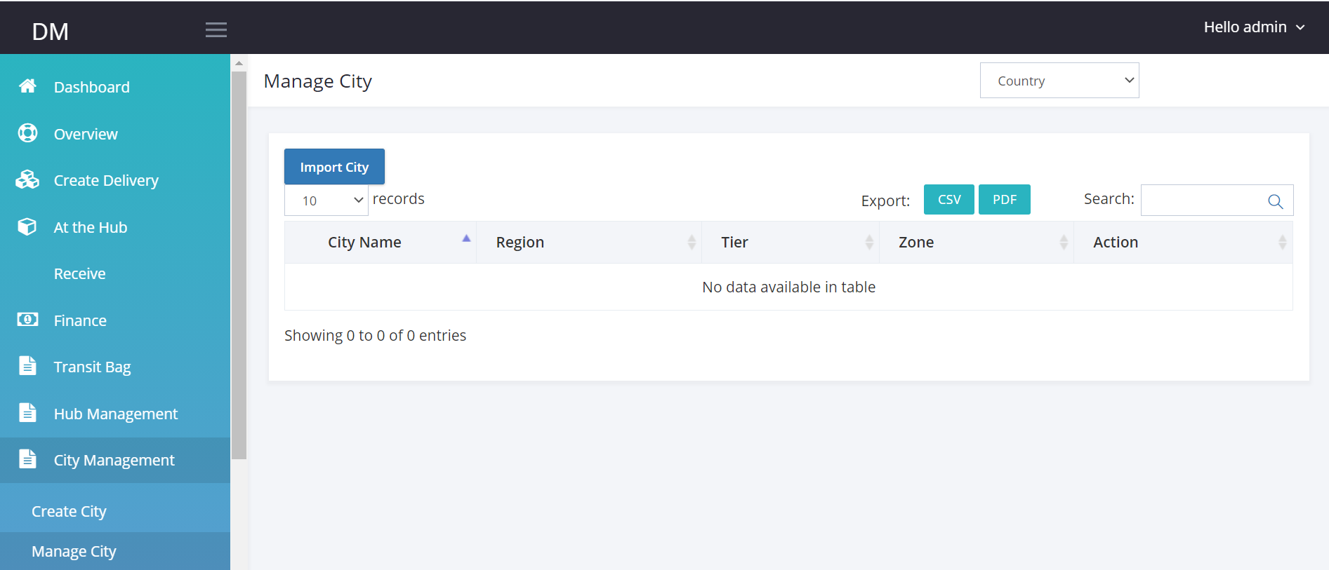

Edit

I should be able to view all Created city Data from Manage city

When I click edit I should be able to edit cities.

Hub Management.

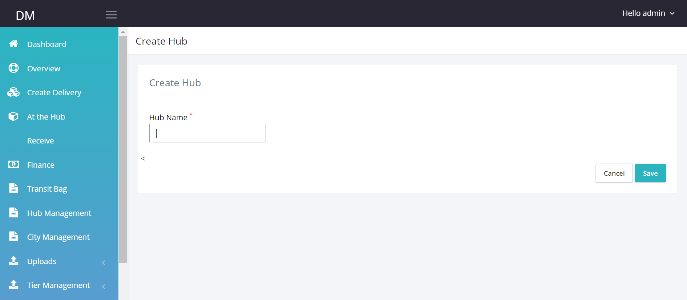

Create Hub

Manage hub

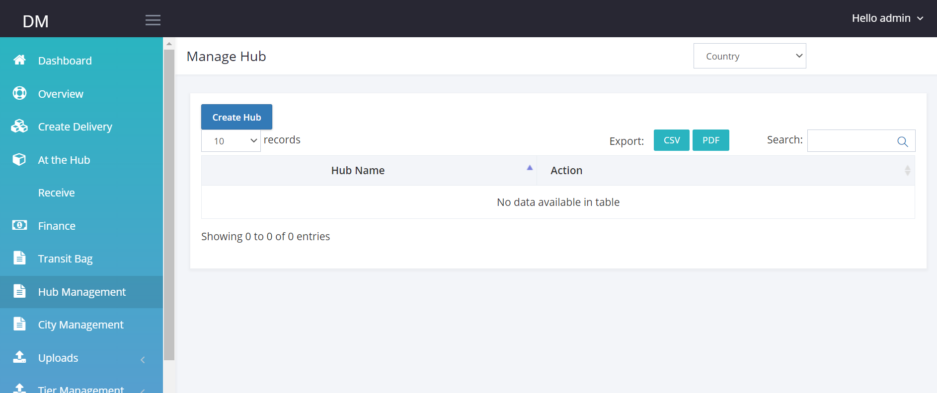

**Task 3**

**Create Delivery**

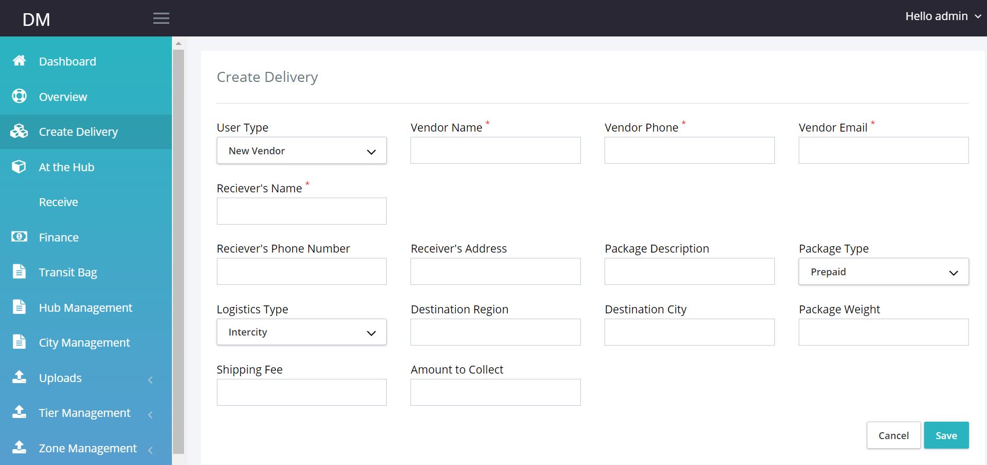

Link the tab to a database.

**User Type:** If user clicks New Vendor, Vendor Name, Vendor Phone and Vendor’s email should be visible and data entered on these field should create new entry on vendor table as well.

If User type already exists, user should be able to select vendor name from the list of available vendors and every other vendor field is populated.

Destination City: This should be selected from available city.

Shipping fee: Check selected City, check inputted weight, add tier and zone amount.

Origin Hub: list of hubs.

Once submit display PDF document ( 2 pages) Invoice and waybill, Then store in pending table

Tracking number is auto generated.

Package status becomes pending.

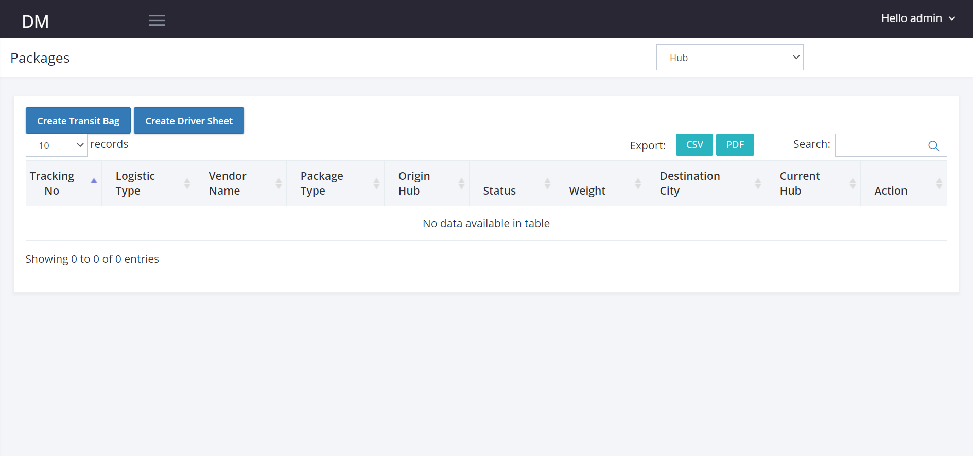

**Receiver’s Name:** Test Test Shipping Fee: Created At

Receiver’s Phone: Amount to Collect: Updated by:

Receiver’s Address: Transit Bag Number: Updated By:

Package Description: Created By:



1045672 Inter-city vendor1 prepaid Hub 1 Pending 2kg Lagos

When I click on the Tracking number, I should see that drop down page.

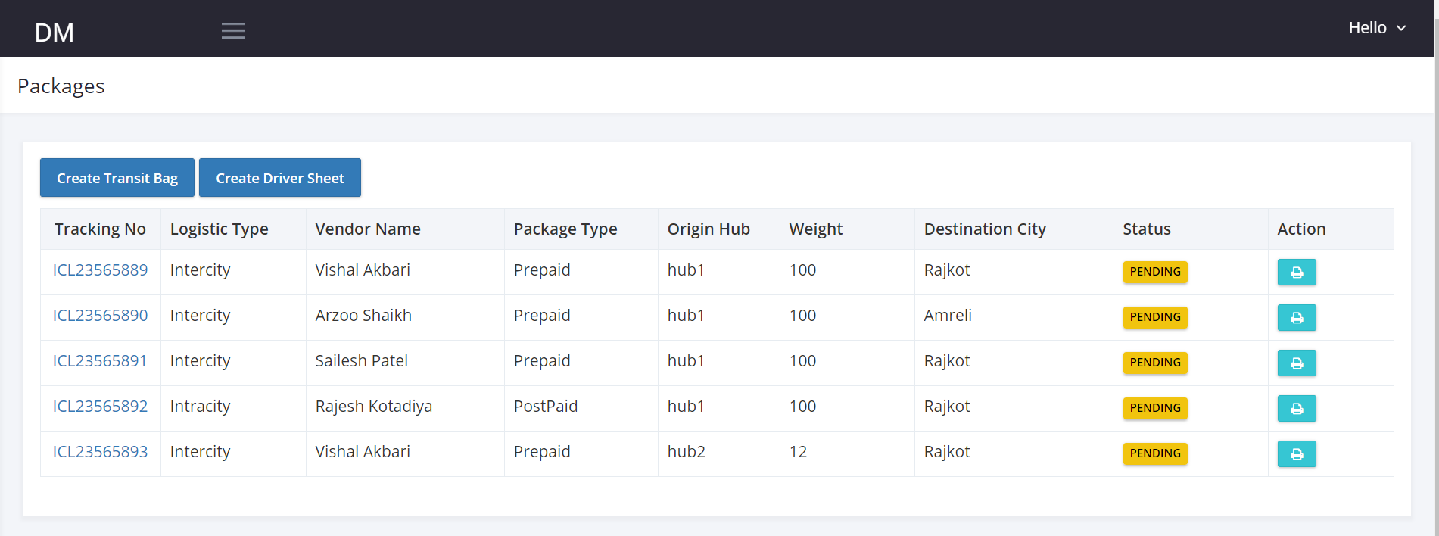

Hub

Hub

Add the Hub Filter to the At the Hub page.

When I click on Create Transit Bag button.

I should see select destination page

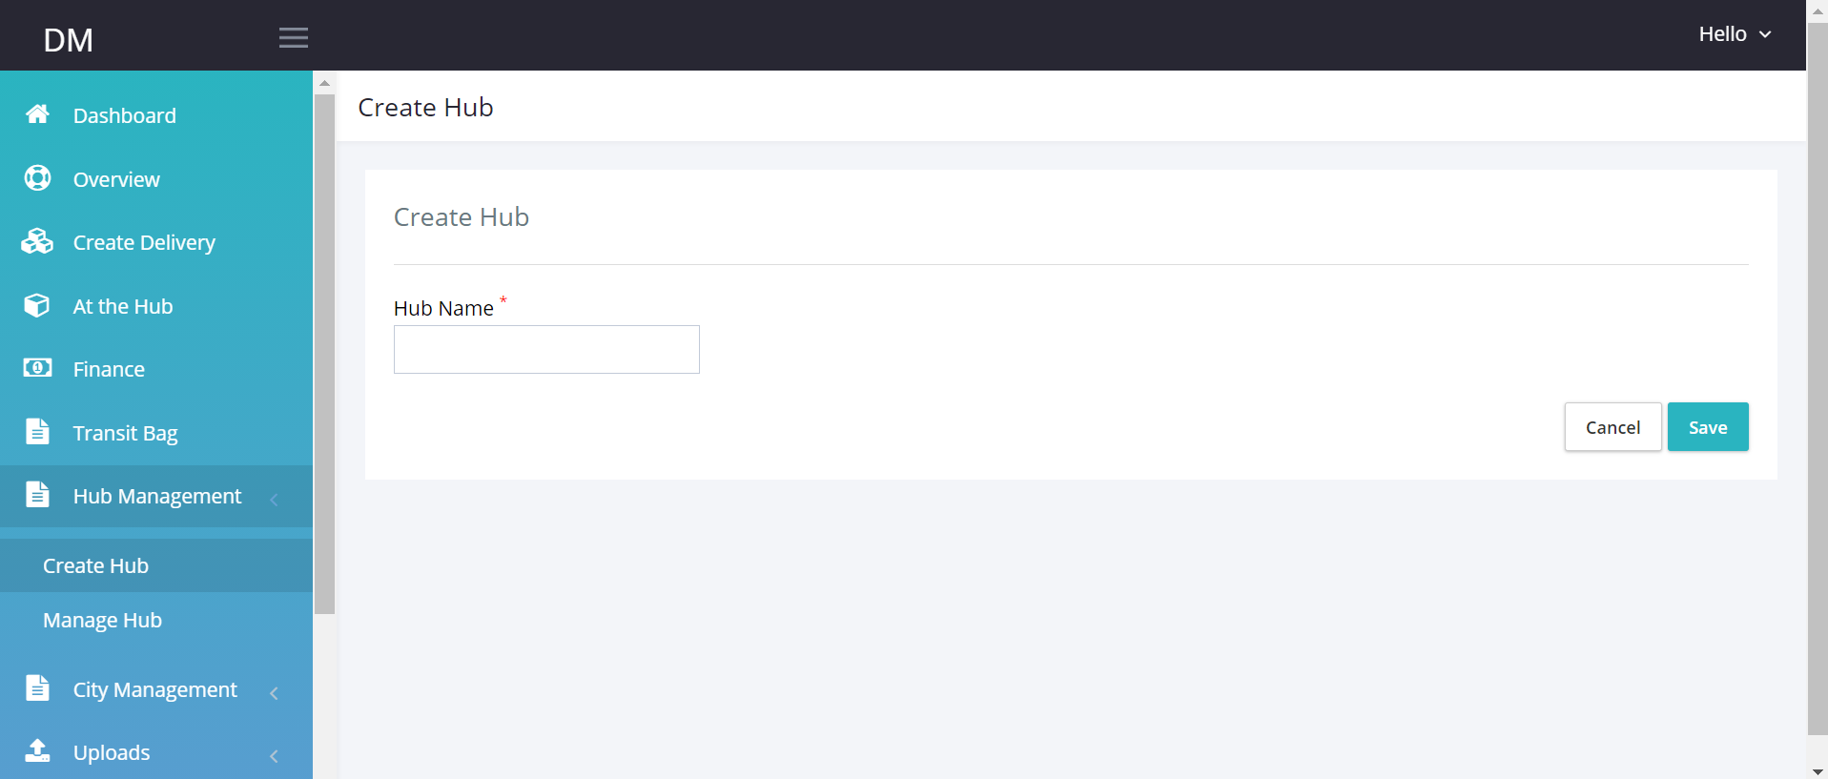

Select Destination Hub

Create Transit bag

Transit Bag

Transit Bag number should be automatically generated.

Select destination hub will be a drop down from available Hubs on the system.

Once can be searchable.

Once selected and click save.

Transit Number is auto generated in this format.

TBHub+random 5 numbers.

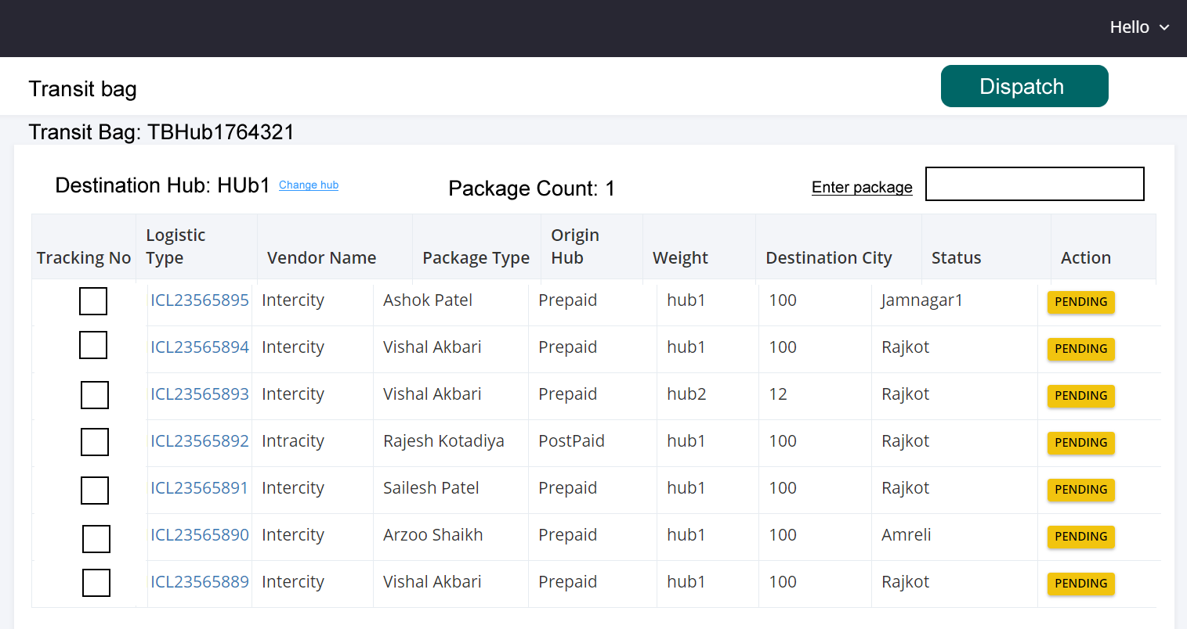

* When I enter tracking number in the search box and click enter, the tracking number should be selected. If tracking number is not found it should say Tracking number not found.
* When the number of tracking numbers selected should be counted on the top of the page. (Package count).
* When I click on change destination hub, I should see list of available hubs.
* When I click on the Dispatch button, the tracking numbers selected should be attached to the Transit Bag number. I should get a pop-up message saying are you sure you want to dispatch? If yes. Then a PDF should be downloaded with the Transit number name , Destination Hub and all the Tracking numbers attached to the Transit Bag.
* After clicking dispatch, I should be redirected to the create new transit bag page.
* When a new transit bag is created it should drop on the transit management Tab.
* Once transit bag has been dispatched, all tracking number attached to it should change status from pending to INTransit.
* When I search and enter same number twice, it should check and uncheck Tracking number.

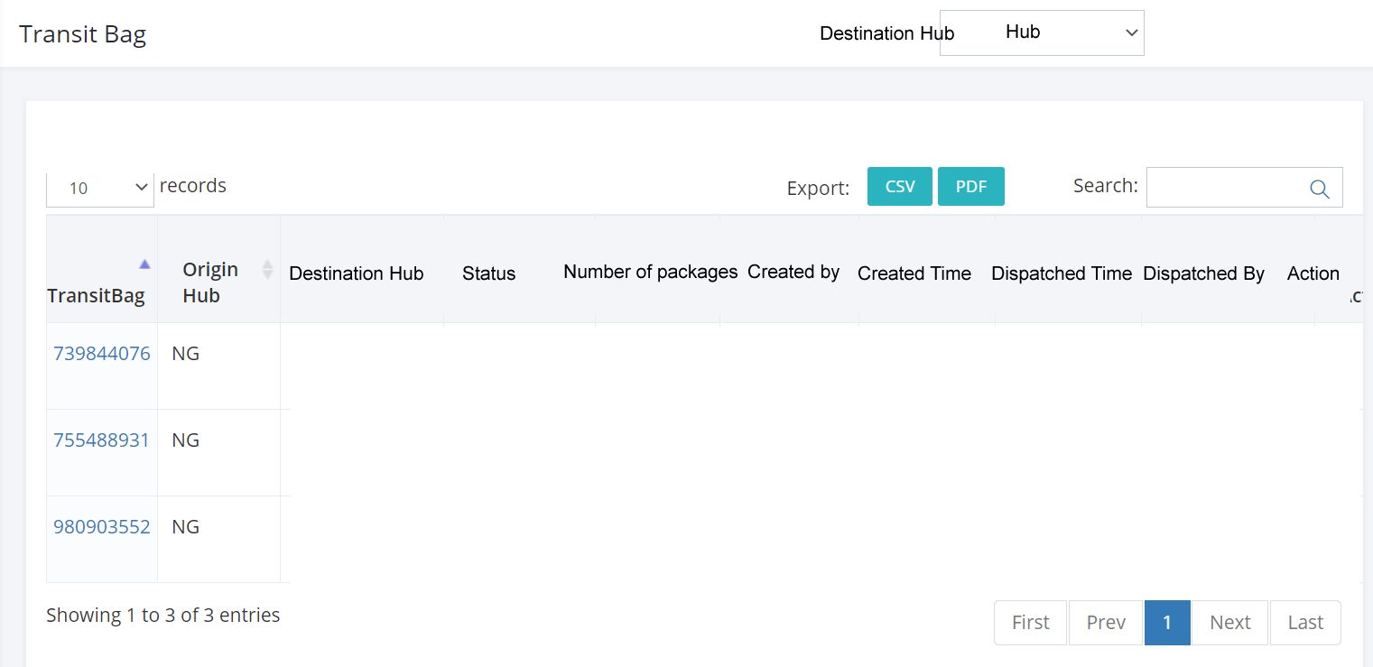

* When I click on the Transit Bag tracking Number, I should see all package number attached to the transit bag.
* When New Transit Number is dispatched, status should be INtransit.

